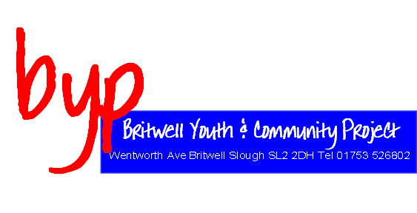

Youth Worker – Sports Development

Reports to: Senior Youth Worker

Location: Britwell Youth & Community Project

Hours: 9 hours per week

Salary: £5095.44

Job Purpose:

Deliver a structured and comprehensive multi-sports programme focusing on activities that young people have requested to include football, cricket basketball & rounders.

Main Duties:

- To make contact and build relationships with young people in a professional, positive and caring manner to support young people
- To support young people to enhance their personal and social development
- To gain feedback from young people and develop activities based on that
- To work co-operatively with colleagues in their respective teams
- To assist in the planning, monitoring and evaluation process in relation to Britwell Youth and Community Project
- Run activity sessions for young people
- To think ‘outside the box’ to engage young people to try activities
- Drive an activity to gain participation from young people
- Complete risk assessments for activities
- To be involved in regular supervision

Person Specification

Key Criteria | Essential | Desirable
Qualifications and Training | Educated to GCSE/NVQ level 2 or equivalent | Part time youth qualification
Competence Summary (knowledge, abilities, skills, experience) | - Ability to work closely with individuals and groups of young people  - Ability to listen and communicate with young people from diverse backgrounds  - Ability to work as a member of a team and work co-operatively with colleagues within the project  - A broad understanding and commitment to equality of opportunity in relation to youth and community work  - An interest in sport | - Current driving license and own transport  - An understanding of issues affecting young people in the community of slough  - Experience of working with a multi-cultural community  - Able to plan, monitor and evaluate sessions  - Experience of working with young people 8 -19 yrs

